**

**MATHEMATICS:**

**SPECIALIST 3 & 4**

**SEMESTER 2 2017**

**TEST 6**

**Resource Free**

Reading Time: 2 minutes

Time Allowed: 24 minutes Total Marks: 24

**1.** [1, 2, 3 marks]

A particle is travelling such that its acceleration is given by $\ddot{x}= -4x$. The particle has a maximum speed of $10$ cm/sec. Initially, the particle has a negative velocity, a positive acceleration, and is $2.5$ cm from its extreme point.

Determine the

(a) period of the motion.

(b) amplitude of the motion.

(c) equation of motion, $x(t)$.

**2.** [2, 6 marks]

(a) A particle travels with a velocity, $v=\sin{2x}$. Show that the acceleration of the particle is given by $a\left(x\right)= \sin{4x}$.

(b) A second particle starts from the origin with a velocity of $6$ metres/second. Its acceleration is given by $a\left(t\right)= e^{-0.2t}$.

Determine

(i) the limiting value of the velocity

(ii) the exact value of the particle’s position at $t=5$ seconds,

**3.** [3 marks]

One hundred One-Eyed, One-Horned, Flying Purple People-Eaters are captured, and the lengths of their horns are measured. These horns have a mean length of $27$ cm with a standard deviation of $8$ cm.

Given that $z_{87} ≈1.5$, determine the $87\%$ confidence interval for the mean length of the horns of all One-Eyed, One-Horned, Flying Purple People-Eaters.

**4.** [2, 5 marks]

The velocity of a particle is given by $v\left(x\right)= \sqrt{3x-12}$.

Determine the

(a) acceleration when $x=2$.

(b) displacement when $t=2$ given that when $t=0, x=7$

**

**MATHEMATICS:**

**SPECIALIST 3 & 4**

**SEMESTER 2 2017**

**TEST 6**

**Resource Assumed**

Reading Time: 2 minutes

Time Allowed: 29 minutes Total Marks: 29

**5.** [2, 2, 4 marks]

$$O$$

$$x$$

A trolley is moving in simple harmonic motion about the origin, $O$. The displacement, $x$ metres, of the centre of the trolley from $O$ at $t$ seconds is given by

$$x=6\sin{(2t+\frac{π}{4})}$$

(a) Find the exact velocity of the trolley when $t=0$.

(b) Determine the exact first time after $t=0$ when the centre of the trolley is at $x=3$.

$$w$$

$$P$$

A particle, $P$, on top of the trolley, is moving in simple harmonic motion about the centre of the trolley. Its displacement, $w$ metres, from the centre of the trolley at time $t$ seconds, is given by

$$w=\sin{2t}$$

The displacement, $y$ metres, of $P$ from the origin is the sum of the displacements $x$ and $w$.

(c) Show that $P$ is moving with simple harmonic motion.

**6.** [5, 2 marks]

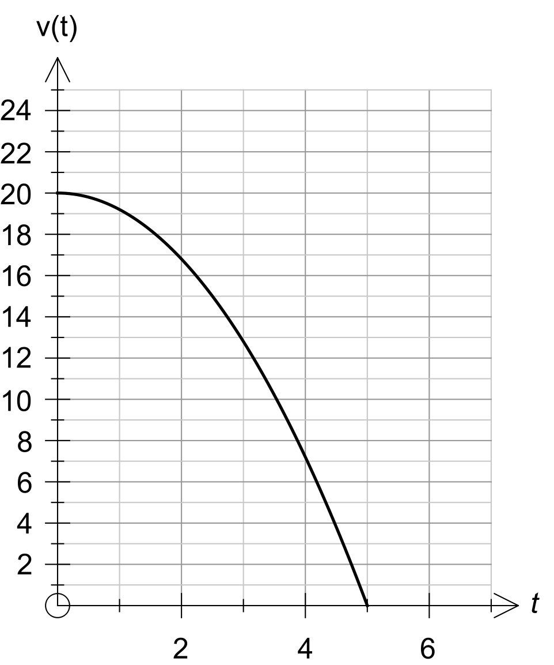 A distracted driver doesn’t notice a stop sign at an intersection, and has to apply the brakes rapidly in order to stop suddenly. The driver goes from $20$ metres/second to stopping in $5$ seconds, so that his velocity, $v(t)$, is shown in the graph below. His acceleration is given by the equation $a\left(t\right)= kt$.

(a) Using calculus, show that the equation of the curve is given by $v\left(t\right)= -0.8t^{2}+20$ m/sec.

(b) Determine the distance the driver travels between applying the brakes and stopping.

**7.** [3, 3, 3, 3, 2 marks]

Andrew and Brad are both training to be in the cycling team at the Olympics. They are of equal ability, with their times to complete races almost identical.

Andrew’s coach has decided to include a lot of training drills that involve riding around an indoor cycle track of length $250$ metres. Each time Andrew completes a lap his time is recorded. Over the duration of his training, the time taken for Andrew to complete one lap has been observed to be normally distributed with mean $μ=18.38$ seconds and standard deviation $σ=0.36$ seconds.

During the final selection trials for the Olympics, Andrew has to complete a $2.5$ kilometre ( $10$ lap) time trial on the indoor cycle track.

Determine the probability that the:

(a) mean time per lap over the $2.5$ kilometre time trial will be between $18.0$ and $18.5$ seconds. Give your answer to four decimal places.

(b) total time taken for the $2.5$ kilometre time trial will be less than $182$ seconds.

Give your answer to four decimal places.

Brad’s coach believes the way to get stronger on the bike is to spend a lot of time doing long rides out on the road, and as such Brad does very little riding on the indoor track.

During the final selection trials for the Olympics, Brad completes the $2.5$ kilometre ( $10$ lap) time trial on the indoor cycle track in $186$ seconds, and it was noted that the standard deviation for his lap times was $0.32$ seconds.

(c) Determine the $98\%$ confidence interval for the mean lap time for Brad, correct to $0.01$ seconds.

(d) How many complete laps would Brad have to complete to be $98\%$ certain that the width of the confidence interval for his mean lap time is less than $0.3$ seconds?

Andrew’s coach claims that his coaching method is more effective than the method used by Brad.

(e) Comment on this claim stating any relevant statistics.